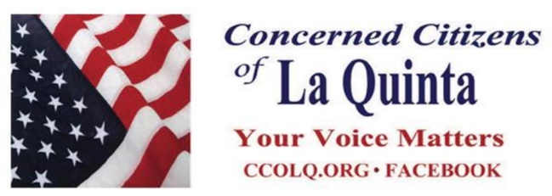
July 2019 Newsletter

Welcome to the CCOLQ Newsletter. This e-newsletter provides information on what issues are in the forefront in La Quinta. We trust that you will find it informative and we invite you to share it with your friends.

In This Issue
Summary of May Meeting
Update from Chairman Sylk
Photos From May Meeting
Valley Voice submission on La Quinta Election Districts Proposal
Letter from Chairman Sylk

To The Members of CCOLQ
What a terrific meeting tonight at The La Quinta Resort from 5:30 to 8:00pm and no one left till the end. Listening to Past Mayor Don Adolph rip into the present Council's decisions, Mike Hestrin the Riverside County DA, County Supervisor and past Speaker of The CA House Manny Perez, Dante Gomez Esq on New Council Districts, Julie Makinen The Executive Editor of The Desert Sun Newspaper, The Salton Sea Directors Bryan Williams and Frank Ruiz, The Mgt Team from The Epoch Times Newspaper, and the always blunt and straight talking Chairman Robert Sylk on how to improve La Quinta was the best ever. The Awards to Hestrin, Perez, and Makinen was met with rousing applause as well as local awards to Gomez, Gray, and Williams. All 185 guests were thrilled. Nice to see Doug Hassett, Mitch Blumberg and others attending. But of course our esteemed City Council stayed away. Next two (2) meetings will be in Oct and Dec.
Robert F. Sylk , Chairman
Concerned Citizens Of La Quinta
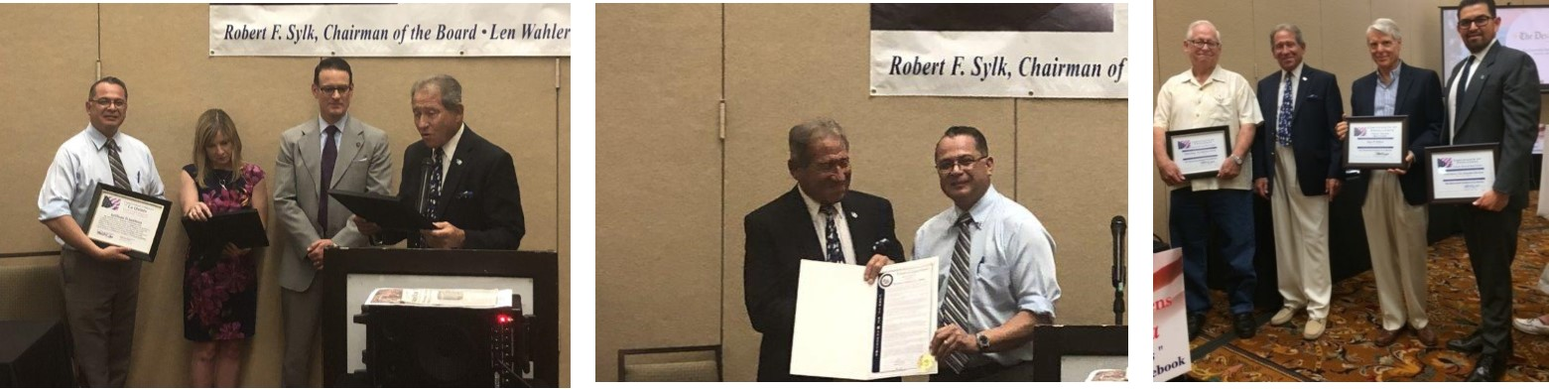

Pic 1. Chairman Sylk presenting Awards to Riverside D.A. Mike Hestrin, Julie Makinen Executive Editor of The Desert Sun Newspaper, Riverside County Supervisor Manuel "Manny" Perez Perez,
Pic 2. Robert presented with The Board of Supervisor's Highest Proclamation Honoring Robert and the CCOLQ Organization for "fulfilling a noble and vital purpose for outstanding civic involvement to the betterment of La Quinta and best wishes for continued success".
Pic 3. Robert Awarded "Certificates of Recognition" to CCOLQ Members Richard Gray, Bryan Williams, and Dante Gomez for their hard work in preparing our issues for tonight's presentation.

Valley Voice submission on La Quinta Election Districts Proposal
Palm Springs, Cathedral City and Indio in recent years have changed their city council elections from “at large” to “by district” systems. As a result, the citizen’s voice and vote can be heard loud and clear by these "more closely" elected representatives, increasing their accountability to residents.
In La Quinta, elected officials have made decisions that some residents believe go against the citizens' best interests. The “Ironman” traffic nightmare that consumed an entire day is a prime example of the everyday citizen's voice being ignored.
The Concerned Citizens of La Quinta seeks to make a change from the current “at large” system to a “districts” system via a five-step process:
Formulate language (petition) and districts;
Submit the petition to the elections official of the City Council;
Circulate an initiative petition and get approximately 15% of the voters in La Quinta to sign (approximately 3,500 voters);
Get the initiative on the ballot and; Vote!
We have formulated a written text of the initiative not in excess of 500 words and a map that divides the city into four proposed districts. After the city of La Quinta approves the language for the petition, we need our volunteers to circulate the approved petition to the prospective voters and gather 3,500 signatures.
This process is going to be time consuming and challenging, but there is no price too high for our elected officials to listen to the voters and be held accountable for what we see as irresponsible decisions.
Here's why this is important:
Back when La Quinta was incorporated, city politics were dominated by Cove residents. That was because, well, the Cove was pretty much the place where most people lived. The developed city of La Quinta of today has changed tremendously, as have the residents, and looks nothing like the city of yesterday. And yet, the political scene is still dominated by Cove residents. We believe it is not representative of our new city and its residents. The needs of all our residents are not being recognized and our city needs to establish districts so that they can have proper representation on our Council.
Today, La Quinta has homes costing in excess of $10 million, behind gates, with professionals owning them, which is a new demographic for our city. These people have their own needs and wants from city government.
On the north side of town, due to affordability of housing there, not behind gates, are families of workers who are employed throughout the valley, many of whom have school-age children. These families have their own needs and wants from city government.
We have new gated communities on the southeast of the city and we have the Cove area and the Central Business area, which are all very distinct districts. The city and its residents' needs have expanded far beyond the Cove area.
We need to have representation of our residents with families and school-age children. In a community of working-class people, we need to have council members from these neighborhoods who understand the needs of the working class and their families. Our council needs to be representative of all of our neighborhoods. We feel this is not happening the way the council is structured at present.
We have to have people who are running for office who represent those neighborhoods. It is the only fair and equitable means to assure that the issues that are important to all of our residents, and not just a select group, are on the council agenda.
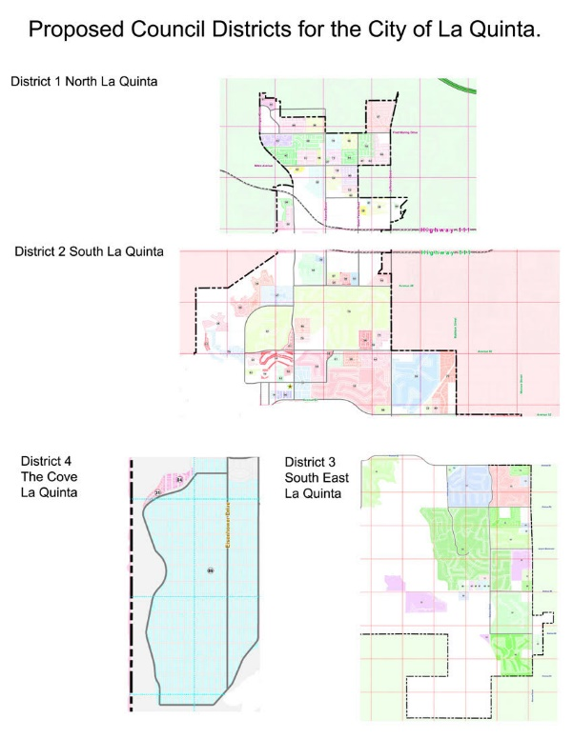

Robert F. Sylk, La Quinta is chairman of The Concerned Citizens of La Quinta Organization. Email him at rsylk77@aol.com.

It has already been nine (9) years that CCOLQ has been on the scene in La Quinta supporting your interests and making the voice of our citizens known. We have now grown to almost 20,000 email members and to continue our efforts to build a greater La Quinta, we need your voice in all we do to help us shape those efforts and present our issues. It's time your Voice is heard. Support change in La Quinta by adding a friend's name to our email list.

We look forward to seeing you at the next meeting in October 2019.

Thank you,
Robert Sylk
Chairman, Concerned Citizens Of La Quinta www.ccolq.org

Our vision is to assist those committed to working together for the betterment of La Quinta and
facilitate open communications on all matters that concern its residents.
For more information please visit our website at www.CCOLQ.org

If you wish to be removed from our mailing list please respond with UNSUBSCRIBE in the subject line.

