

**May Meeting**

***Welcome to the CCOLQ Newsletter. This e-newsletter provides information on what issues are in the forefront in La Quinta. We trust that you will find it informative and we invite you to share it with your friends.***

**May**

**At the La Quinta Embassy Suites Hotel 5:30pm**

50777 Santa Rosa Plaza, La Quinta, CA 92253

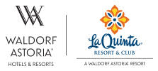

Our Next Meeting will be May 1111, 2018 5:30pm at

***La Quinta Resort & Club***

[49-499 Eisenhower Drive](https://maps.google.com/?q=49-499+Eisenhower+Drive+%0D%0A+La+Quinta,+CA+92253+%0D%0A+Ph:+(760&entry=gmail&source=g), [La Quinta, CA 92253](https://maps.google.com/?q=49-499+Eisenhower+Drive+%0D%0A+La+Quinta,+CA+92253+%0D%0A+Ph:+(760&entry=gmail&source=g)

|  |
| --- |
| **In This Issue** |
| Summary of March Meeting |
| FPPC Complaint against LQ City Manager Frank Spevecek |
| Speaker Line-up For May 23rd Meeting: Keynote Speaker, Secretary of State Candidate Mark Meuser |
| New Salton Sea Science Community Education Roundtable Team |
| Letter from Chairman Sylk |
|  |
|  |

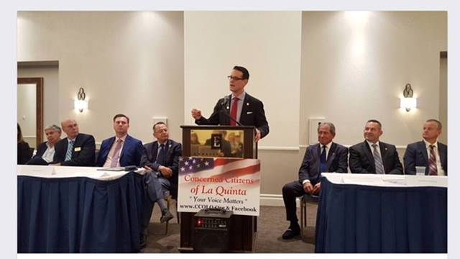

Riverside County DA Mike Hestrin with County Supervisor Manny Perez to his right and Robert Sylk to his left along with 18 other candidates (9 on either side) for Federal, State, County, and local La Quinta offices (US Senate, US Congress, County Sheriff, Attorney General, State Assembly, State Senate, Riverside County DA, with 200 in attendance. Concerned Citizens of La Quinta and Sylk received Awards from the State Senate, County Supervisor and Appreciation from the District Attorney. The evening went overtime as each candidate was allowed 5 minutes to speak and with Chairman Sylk's remarks followed by past Mayor Adolph, LQ Council members Fitzpatrick and Pena, the Pledge of Allegiance and Blessing from Chabad Rabbi Katz and then Q & A we adjourned at 8:15pm. A really great evening. Next one in late-May. Sylk is sitting next to the two (2) County Sheriff's Candidates Dave Brown and Chad Bianco.

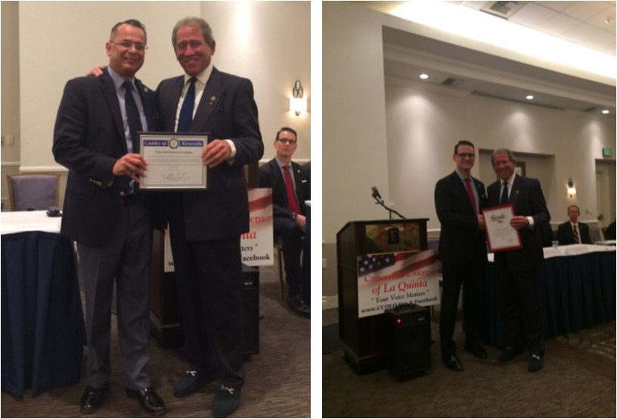

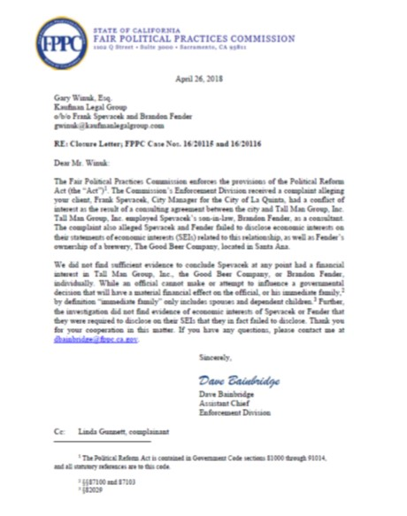

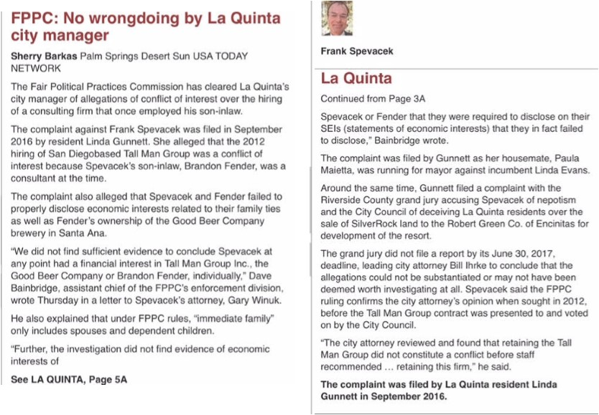

**Our CCOLQ Answer**

We hope that this article will at least raise concerns about the city manager. It basically says that Frank has personal connections with city contractors.  And it appears that those connections were not rigorously examined for any undue interests.  No legal measures meet the very restricted limits of family interests.  But, you don't have to be a conspiracy nut to wonder whether or not Frank would favor his son-in-law's interests to some extent, even if not within the narrow legal restrictions.

All in all, this article raises concerns about Frank as city manager for La Quinta.  We hope people carry these concerns forward since we believe he has too much power, earns too much, and probably overpowers the council members who are only part-time office holders.

List of Distinguished Candidates invited to speak on May 23rd at The La Quinta Resort

**Travis Allen,   Governor of California**

**Paul Taylor,    US Senate**

**Mark Meuser, CA Secretary of State**

**All six (6) US Congressional Candidates**

**Paula Maetta, Mayor of La Quinta**

**Joseph Johnson, City Council of La Quinta**

**Salton Sea Education & Research Committee**

This “community at large “ Roundtable concept proposed is critical in leveraging the efforts ongoing with the SS and educating all parties on the actual research by so many concerned organizations and agencies. We are very fragmented in who, what, and where on current studies ongoing and results of their efforts results in frustration and confusion.  These forums of all the separate organizations speaking as one could reveal over time a series of solutions and actions benefiting our community's health, welfare, and economy.

Step 1 is Education and Outreach in pulling our community together.

Please join with us in our discussion in furthering to initiate this theme at the CCOLQ meeting to bring this issue to the forefront to consider supporting our initial Salton Sea Science Roundtable. This newly formed team will be establishing the agenda for the first of a series community roundtables addressing the science and efforts underway.  Remember, a huge part of our outreach and dialogue will be for our next generation

Al Hurt

College of The Desert Co-Chair SS Education and Research Committee

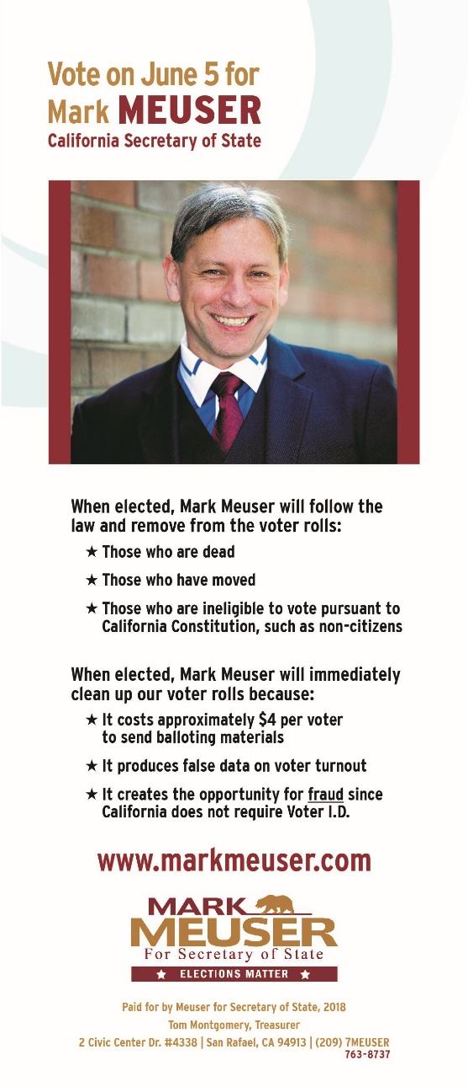

**Term Limits for Council plus other remarks:**

Folks, we now know that there is a leadership vacuum in La Quinta. Let us now open up the doors for those whose ideas and enthusiasms can sustain us for decades. An atmosphere which welcomes ideas is a necessary prerequisite for an innovative city government unlike La Quinta. Therefore I propose term limits of four- two (2) year terms for Mayor and two - four (4) year terms for council. Our Founding Fathers, Benjamin Franklin and Thomas Jefferson said "Lifetime politicians are not the answer. Be elected, do your job, and go home". As the month of May begins, and for the last several years it is evident that we lack a coherent framework to attract investment, and that is why we need new leadership in this city. Our leaders need to attract attention, maintain interest, create desire, and get action. Has any of that happened? Should we be expected to live with some of the decisions that our current crop of leaders issue in the coming year?  Absolutely Not.

What are their major accomplishments? Can't think of any because there are none unless you consider raising taxes, spending our money to enlarge the parking lot at the top of the cove, Councilman Roberto Radi trying to force Closed Circuit Cameras on us,  joining the CV Link without a vote, and the continuing SilverRock amateurish business decisions fiasco.

Look around the community, Look if there are others who do what we do, Look at those who believe what you believe and realize how much we have in common. We have much to gain by utilizing our power together to truly inspire new leaders. We have an opportunity and responsibility that each of us has, though action and results, to show that our vision is clear, our values are powerful, and our mission is compelling.  
Together we can do the Extraordinary, especially at the polls this November 6th.

Robert F. Sylk  
Chairman of the Board

Concerned Citizens of La Quinta [www.ccolq.org](http://www.ccolq.org)

Our vision is to assist those committed to working together for the betterment of La Quinta and   
facilitate open communications on all matters that concern its residents.

For more information please visit our website at www.CCOLQ.org

*If you wish to be removed from our mailing list please respond with* ***UNSUBSCRIBE*** *in the subject line.*